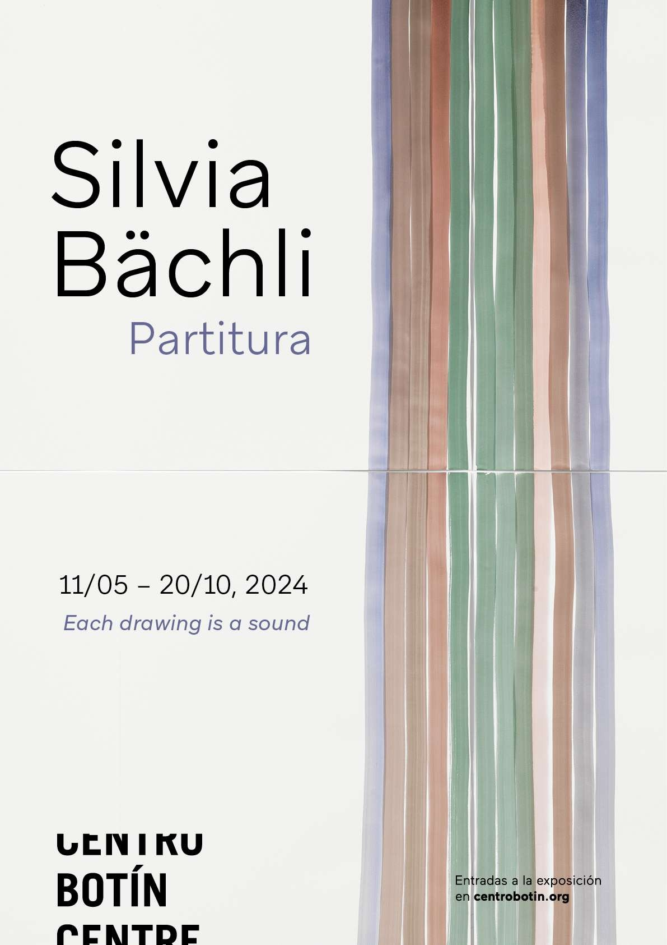

CENTRO BOTÍN PRESENTS
PARTITUTA

A SOLO EXHIBITION DEDICATED TO ARTIST SILVIA BÄCHLI

- The exhibition marks the Swiss artist's first institutional exhibition in Spain, offering a comprehensive look into her evolving drawing practices.

- Featuring a series of new works including Farbfeld (colour fields), as well as a wall installation in collaboration with Eric Hattan and works from her emotive presentation in the Swiss Pavilion at the 53rd Venice Biennale.

- Curated by Bárbara Rodríguez Muñoz, the exhibition is accompanied by a new publication in both English and Spanish designed by Manuel Raeder (BOM DIA BOOKS) that includes newly commissioned texts by poet and critic Quinn Latimer, writer Chris Fite-Wassilak and a conversation between Bächli and Rodríguez Muñoz.

- The exhibition is the most recent example of Centro Botín´s commitment to drawing practices, which started with scholarly and curatorial research on Francisco Goya and Manolo Millares and expanded to other regions and contemporary contexts with Julie Mehretu and Juan Muñoz.

Exhibition Dates: 11 May – 20 October 2024
Press Preview: Friday, 10 May 2024

Download images here

Running from 11 May to 20 October 2024, Centro Botín (Santander, Spain) presents Partitura - an exhibition showcasing recent and new works by Swiss artist Silvia Bächli (born 1956, Baden) in dialogue with earlier drawings. Since the late 1970s, Bächli has committed to drawing as a practice that is deeply dependent and entangled with her body and its movements, both within the domestic sphere and the landscape. Her drawings can be read as traces of sensorial records– a walk on a field, a body that aches, a poem that triggers - and corporeal gestures – the extension of the arm, the strength of the hand or the rhythm of the brushstroke. Bächli says: “Drawings are actions. Lines tell stories. What do these lines do? Where is the beginning of a line, does it touch another line? How does it touch them? Words appear, which ones come to the tongue?”

For this exhibition, Bächli has created a score for the gallery space: a sequence of rhythmic clusters of drawings hung at various heights and intervals which, room after room, accrue meaning in their persistent accumulation. Bächli insistently works with modest and limiting means: white paper of different sizes, qualities and tones

marked with Indian ink, charcoal, gouache or pastels. Her process is sequential as the artist draws on sheets from a pile, one after another, arranging constellations of works on her studio wall that are consecutively interrogated, rearranged, rejected, until she discovers something that feels right and surprising.

The exhibition sheds light on both the continuity and the progressive changes that occur in her work: from her black and white nervy body fragments and self-absorbed female figures, to her burnt orange interpretations of the grid structure or her recent expansive coloured surfaces. The exhibition includes Das, Bächli´s installation at the Swiss Pavilion for the 53rd Venice Biennale in 2009, as well as a wall installation in collaboration with Eric Hattan.

The exhibition is curated by Bárbara Rodríguez Muñoz, Director of Exhibitions and The Collection at Centro Botín. Muñoz says: “Silvia´s simple and sensual visual propositions depart from her consistent use of the line and the variability of the brushstroke as a basis for expression, resulting in wall compositions that seem to agency: to breathe, move, rest, or shout. They embody Silvia´s exquisite acts of care and attention when she engages with her surroundings, elevating every small and mundane gesture. It has been an honour and a joy to accompany Silvia in the process of crafting this expansive exhibition, to think with her about the show´s rhythm, textures, melody and how our visitors will immerse themselves in the “partitura” (score) she has created for Centro Botín”.

Visting the exhibition

Upon entering the exhibition, visitors are faced by a doorframe crowned by your colour fields – horizontal or vertical compositions of solid-coloured surfaces followed by a selection of nervy figures and fragments from the early 80s combined with recent works. From here visitors walk through Tische (Tables) (1983-2017), an arrangement of figurative and abstract drawings that create various ‘collections’ in flat display tables. In contrast to her wall installations with their rhythmic structures - that remind us of musical scores - in Tische the artist arranges the drawings into technical, formal or thematic “collections” in a non-linear fashion inviting us to find sequences and follow trails and suggesting an intimate and fragmented experience of perception.

The exhibition continues with a room dedicated to Bächli’s grids, featuring Rotes Zimmer (2011) a series of drawing using acrylic and gouache where the artist performs the multiple interpretations of the basic grid, one of the key structures of 20th Modern Art. In this series the artist varies the brushstroke moving from left to the right and laying a significantly different trail. These drawings are hung on top of each other to create irregular structures that appear to stretch out of the sheet and into the exhibition space.

The exhibition continues with Das (“German pronoun corresponding to “that” or “it”), Bächli’s installation for the Swiss Pavilion at the 2009 Venice Biennale, inspired by Inger Christensen, one of the most renowned European poets of the 20th Century and whose poetry was designed to distort language to allow the disclosure of

other patterns and other principles of order, such as the organic interconnections of existence. Following from Bachli´s 4-month residency in Iceland, the resulting fragmented and evocative drawings and photographs suggest a filmic view of her perceptions of the landscape. They create an embodied impression of nature, not as something that can be used or exploited, organised or taken in one glance, but as a sensory world where beings become entangled through the senses. Also on display is Farbfeld (Colour Field) (2022-2024), a new body of works on paper measuring 102 by 72cm that began in 2022. Bächli uses gouache paint, a water-soluble material that has a broad spectrum of consistencies, to create coloured surfaces that range from translucent to opaque exploring in this way the fluidity and texture of paint. Through their material modesty, the simplicity of their visual proposition, and their self-contained nature, these artworks lead the us into contemplation. Additionally on view, To have a shelf life (2017 - present) is a collaborative installation with Eric Hattan, utilising reclaimed shelves featuring a horizontal black line, arranged like a puzzle in the space, covering the walls. The exhibition’s journey concludes with Lange rote Linien (2022), a composition of drawings with 4 meters long lines painted across that illustrate the speed of movement as well as the direction of the artist’s gaze presented alongside a series of intriguing coloured plaster sculptures resembling figure heads.

ENDS

For all press enquires please contact Sutton:
Ginevra Berghinz, ginevra@suttoncomms.com, +44 (0) 7452 787 176

NOTES TO EDITOR
Centro Botín, Muelle de Albareda s/n, Jardines de Pereda, 39004 Santander, Spain
Opening Times: Tuesday to Friday, 10am to 2pm and 4pm to 8pm. Weekends and holidays, 10am to 8pm.
General admission: €8 (€9 box office). Concession €4(€4,5 box office) Free Entrance: 18 May (Museum Day) & 12 October (Hispanic Day) www.centrobotin.org/en/

About Silvia Bachli
Silvia Bächli (Baden, Switzerland, 1956) lives and works in Basel. Her upcoming solo exhibitions include Dass eins zum andern wurde. Welches welches ist? at Kunst Museum Winterthur (2024) and Partitura, Centro Botin, Santander (2024). Important solo exhibitions have been dedicated to her including Museum Langmatt, Baden, Switzerland (2023); Weserburg Museum für moderne Kunst, Bremen, Germany (2022), Fidelidade Arte, Lisbona (2021) and Culturgest, Porto (2021); Fondation espace écureuil, Printemps de septembre, Toulouse (2021), Kunsthalle Karlsruhe (2019); Centre culturel suisse, Paris (2017, with Eric Hattan); Pinakothek der Moderne, Munich (2014); Kunstmuseum St. Gallen (2012).

…………………………………..

About Centro Botín
Set in the heart of Santander, Centro Botín opened its doors to the public in 2017. Designed by the renowned architect Renzo Piano, it is the most ambitious project of the Fundación Botín to date and is one of the leading international arts centres. It presents an outstanding, experimental and inspiring programme of exhibitions, publications and public activities that, alongside it´s collection, respond to and ignite contemporary debates within the fields of art and culture while awakening audiences’ creativity.

Centro Botín is a place of encounter, situated in a unique enclave in the heart of the city and overlooking the bay, it has become a cornerstone in the cultural arc of the Cantabrian Coast. Its mission is to create a greater understanding of art and foster its power to stimulate and develop creativity and emotional intelligence. Fundación Botín aims to bring social and economic strength to the communities it supports, with Centro Botín making a major contribution to helping promote Santander and the wider region on both the national and international stage. Since its opening in 2017, it has staged a programme of historical and contemporary exhibitions including Agility and Audacity: Goya´s Drawings; Picasso Ibero; Joan Miró: sculptures; Julie Merethu: A Universal History of Everything and Nothing; Carsten Holler: Y; Anri Sala: As you go; Martin Creed: Amigos; Ellen Gallagher with Edgar Cleijne: A Law… a blueprint … a scale; Damián Ortega: Expanded View; Roni Horn: I am Paralyzed with Hope; Enredos: Eva Fábregas; El Greco / Tino Sehgal and Shilpa Gupta: I Live Under Your Sky Too.

www.centrobotin.org/en/ www.centrobotin.org/en/

